**Exercices**

**Convert the following ER-Diagram schema into its corresponding Relational database schema.**

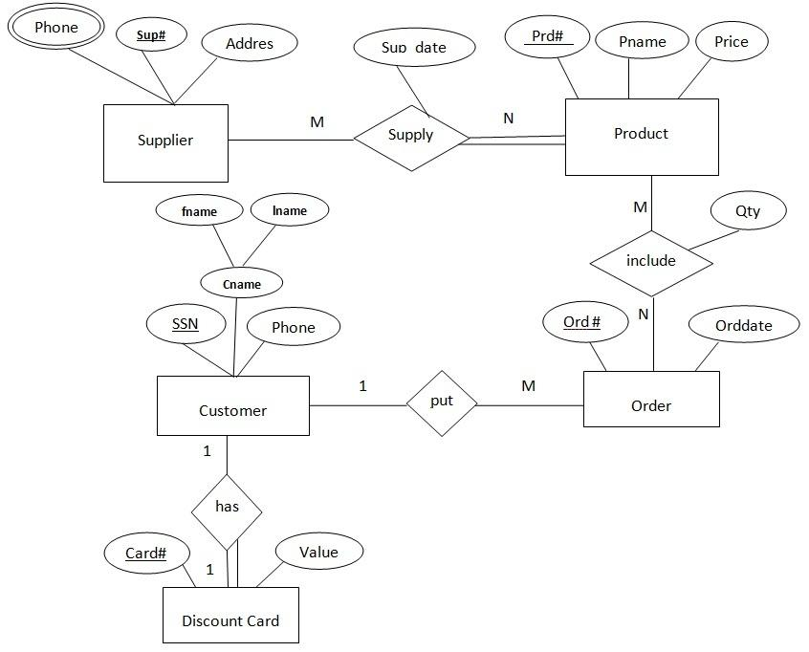

**Convert the ER-EER into its corresponding Relational database schema.**